**AWS Project using SHELL SCRIPTING for DevOps**

**Introduction**

In the real-world DevOps scenario, The AWS Resource Tracker script is widely used to provide an overview of the AWS resources being utilised within an environment.

It aims to help organisations monitor and manage their AWS resources effectively. The script utilises the AWS Command Line Interface (CLI) to fetch information about different AWS services, such as S3 buckets, EC2 instances, Lambda functions, and IAM users.

**What does this project do?**

By running the AWS Resource Tracker script, users can quickly obtain a list of S3 buckets, EC2 instances, Lambda functions, and IAM users associated with their AWS account.

This information can be valuable for various purposes, including auditing, inventory management, resource optimisation, and security assessment.

**Build the project**

**Create EC2 Instance**

**Step 1.** Go to your AWS account and log in, then search for EC2 Instances in the search bar. Or you can click on the services button that is on the top left corner of your dashboard, from there also you can search for the same.

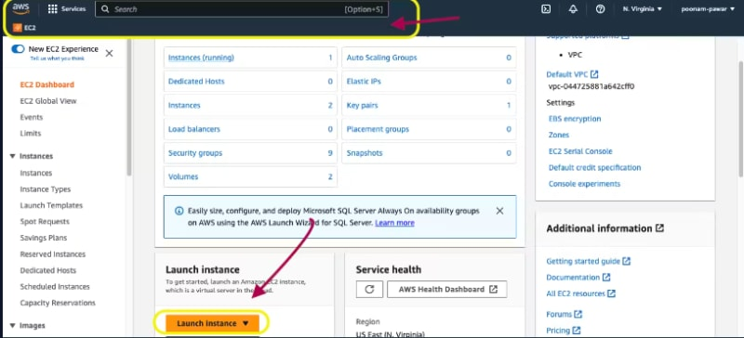

**Then click on the Launch Instance button.**

**Step 2**. Give it a name of your choice, ubuntu as a machine image, select your key-pair or create one if not have any. Leave the instance type t2.micro ie free tier as the same and click again on the Launch Instance button.

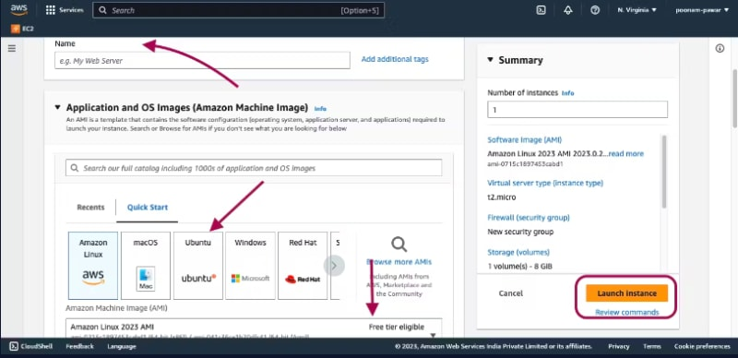

Now you can see your instance up and running like this.

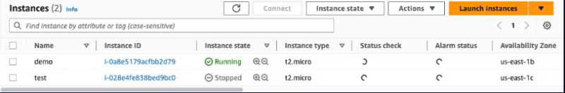

Step 3. Now click on the instance id which will give you detailed information about the running instance, there copy the public IP address.

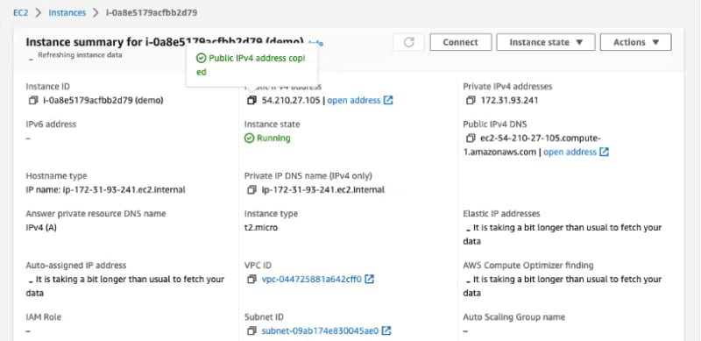

Run the Instance

**Create the Script**

**Step 5.** Now create a shell script file named ***aws_resource_tracker.sh*** and copy and paste the below script.

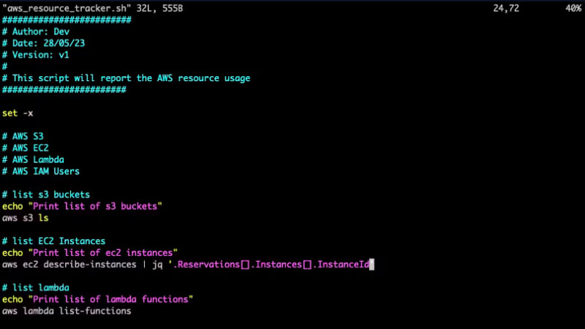

The commands aws s3 ls, aws lambda list-functions and aws iam list-users print the information of the given statement.

**The command**

***aws ec2 describe instances | jq '.Reservations[].Instances[].InstanceId'*** will give you all the Instance IDs present in your aws in JSON format.

**Test the script**

**Step 6.** Run the below command to see the output.

**./aws_resource_tracker.sh**

**The output will look like this.**

